Introduction
The Drill Through – Account Details form allows Planners to plan and review plans at the account level across all Entities, Funds, and Chart1s.

The form provides an easy way to navigate from high level Entity, Fund and Chart1 for a single account to the lowest level of details of planning data for that particular account. With the breadcrumb provided at the top of the form, Planners can quickly return to the high level view.

When would I use this functionality?
Use this form when you want to:
- View and update a single account for multiple entities under an Org node
- Make quick updates to your Forecast data for a single account across multiple Entities, Funds or Chart1s

Using the Form
- From the CalPlan Task List, select Drill Through – Account Details
- Select your point of view (POV) from the drop-down lists for:
  - Entity
  - Fund
  - Chart1
- Click the arrow to refresh the data
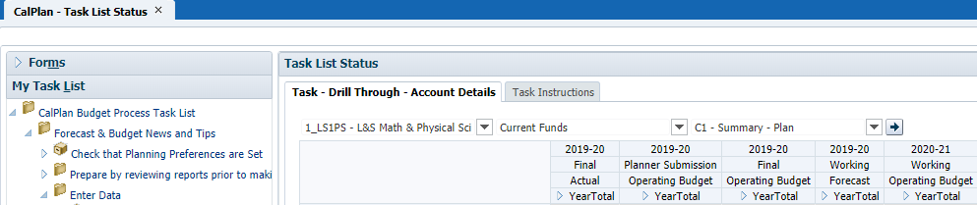

- The form displays the Period collapsed to YearTotal. Click the to expand the form to see quarters and months
- Right-click on an account and select Acct Details by POV to see the detailed data

Drill Through – Account Details – Acct Details by POV
The form displays all DeptIDs for the Entity, Fund, and Chart1 selected for which there is Actual or Plan data. Planners may edit the open months of the Forecast and all months of the Operating Budget for the following year.
To return to the summary view, click the Drill Through – Account Details hyperlink.
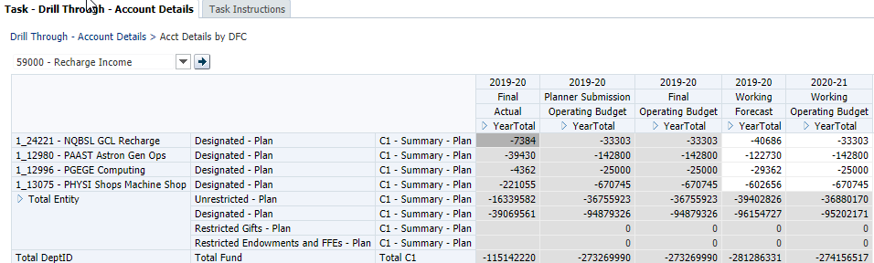

Identify Variances
As you review the data comparing your plan for the year (Final Operating Budget) and where you currently expect to end the year (Working Forecast), your unit may decide to make adjustments. In this example, DeptID 1_10075 is not on track to spend the full $20,395 it budgeted for the year on Computer Service and Software. If the unit believes it will indeed spend that amount, you will need to modify the Forecast.
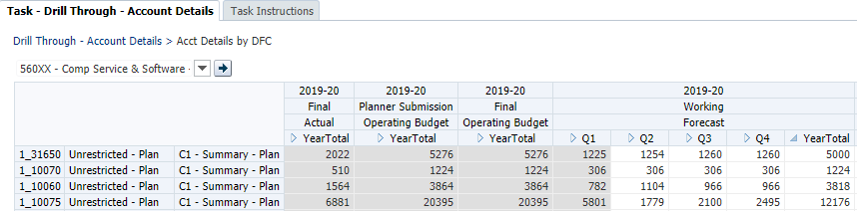

Make Adjustments
In this form, you can enter amounts in each month or you can enter an amount in YearTotal or a Quarter and have CalPlan spread the total to the months. CalPlan spreads the total in the same proportion as the values currently entered in the monthly detail.
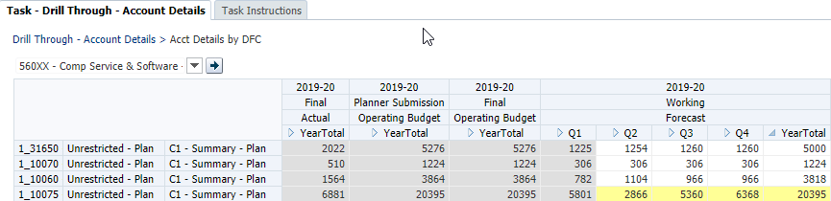

Save Changes
When you enter data in CalPlan, you must click the Save icon to commit your edits to the database.
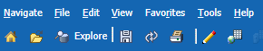

In addition to saving at the detail screen, we recommend that you also save at the summary view. Saving at the summary view updates the calculations that summarize data from the DeptID up to the higher level entity, e.g. Department, Division, etc. so that these update correctly.

CalPlanning automatically aggregates these summary calculations as part of the planning data updates that occur at 9AM, 12PM, 3PM, 6PM and 9PM daily. However, if you want to see your changes in CalPlan reports immediately after entering changes in CalPlan, you will need to save data at the summary level.

